Advanced Artificial Intelligence
3. Variational Autoencoders
3.1 Introduction: Basic components of Variational Autoencoders(VAEs), Architecture and training of VAEs the loss function, Latent space representation and inference, Applications of VAEs in image generation.
3.2 Types of Autoencoders: Undercomplete autoencoders, Sparse autoencoders, Contractive autoencoders, Denoising autoencoders, Variational Autoencoders (for generative modelling) PAST QUESTIONS:
- Explain Contractive autoencoders. (M25)
- Explain Sparse autoencoders in detail. (M25, M24)
- Draw and explain the architecture of Variational Autoencoder. (D24)
- Explain any three variants of Autoencoders. (D24)
- Explain Variational Auto Encoders in detail. (M24)

NOTES:

*Autoencoders :-
Autoencoders are a special type of neural networks that learn to compress data into a compact form and then reconstruct it to closely match the original input. They consist of an:
- Encoder that captures important features by reducing dimensionality.
- Decoder that rebuilds the data from this compressed representation.
An autoencoder’s architecture consists of three main components that work together to compress and then reconstruct data which are as follows:

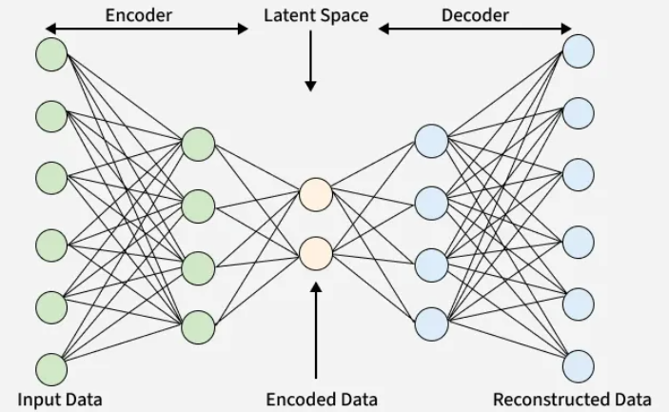
1. Encoder: It compress the input data into a smaller, more manageable form by reducing its dimensionality while preserving important information. It has three layers which are:
- Input Layer: This is where the original data enters the network. It can be images, text features or any other structured data.
- Hidden Layers: These layers perform a series of transformations on the input data. Each hidden layer applies weights and activation functions to capture important patterns, progressively reducing the data's size and complexity.
- Output (Latent Space): The encoder outputs a compressed vector known as the latent representation or encoding. This vector captures the important features of the input data in a condensed form.
2. Bottleneck (Latent Space): It is the smallest layer of the network which represents the most compressed version of the input data. It serves as the information bottleneck which force the network to prioritize the most significant features. This compact representation helps the model learn the underlying structure and key patterns of the input helps in enabling better generalization and efficient data encoding.
3. Decoder: It is responsible for taking the compressed representation from the latent space and reconstructing it back into the original data form.
- Hidden Layers: These layers progressively expand the latent vector back into a higher-dimensional space. Through successive transformations decoder attempts to restore the original data shape and details
- Output Layer: The final layer produces the reconstructed output which aims to closely resemble the original input. The quality of reconstruction depends on how well the encoder-decoder pair can minimize the difference between the input and output during training.

*Variational Autoencoders (VAEs) :-
Variational autoencoders (VAEs) are generative models used in machine learning (ML) to generate new data in the form of variations of the input data they’re trained on.
A Variational Autoencoder (VAE) is a generative deep learning model that learns to represent input data in a compressed, probabilistic latent space. Unlike traditional autoencoders that map inputs to fixed vectors, VAEs map inputs to probability distributions, allowing them to generate new, realistic data samples.
In addition to this, they also perform tasks common to other autoencoders, such as denoising.
Like all autoencoders, variational autoencoders are deep learning models composed of an encoder that learns to isolate the important latent variables from training data and a decoder that then uses those latent variables to reconstruct the input data.
However, whereas most autoencoder architectures encode a discrete, fixed representation of latent variables, VAEs encode a continuous, probabilistic representation of that latent space. This enables a VAE to not only accurately reconstruct the exact original input, but also use variational inference to generate new data samples that resemble the original input data.
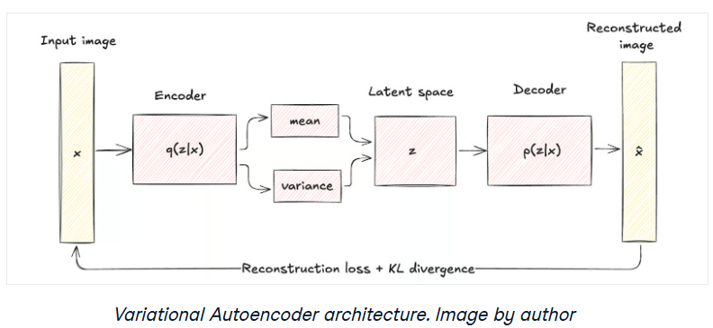
1. Encoder Network: The encoder takes input data like images or text and learns its key features. Instead of outputting one fixed value, it produces two vectors for each feature:
- Mean (μ): A central value representing the data.
- Standard Deviation (σ): It is a measure of how much the values can vary.
This approach encodes each input into a distribution rather than a single point, adding a layer of variability and uncertainty.
2. Latent Space: Instead of encoding the input as one fixed point it pick a random point within the range given by the mean and standard deviation. This randomness lets the model create slightly different versions of data which is useful for generating new, realistic samples.
3. Decoder: The decoder takes the random sample from the latent space and tries to reconstruct the original input. Since the encoder gives a range, the decoder can produce new data that is similar but not identical to what it has seen.

*Contractive Autoencoders :-
A Contractive Autoencoder (CAE) is a type of regularized autoencoder designed to learn robust and stable feature representations by making the encoder less sensitive to small changes in the input data.
In order to achieve this we must add a regularizer or penalty term to the cost function that the encoder is trying to minimize.
Unlike traditional autoencoders that only minimize reconstruction error, a Contractive Autoencoder adds an additional regularization term to its loss function.
CAE prevents overfitting and enhances model generalization making CAEs especially powerful for tasks requiring robust feature learning.
In a standard autoencoder, the model learns to reconstruct the input accurately, but the learned latent features may change significantly even for small variations in the input.
A Contractive Autoencoder addresses this issue by encouraging the encoder to be locally invariant, meaning:
Small changes in the input should produce only small changes in the encoded representation.
This results in more stable and meaningful features.
The key addition is a penalty based on the Jacobian matrix of the encoder.
Jacobian Matrix
The Jacobian measures how much the hidden representation changes with respect to the input:
$$J_{f}(x)=\frac{∂h}{∂x}$$
If the Jacobian has small values, the hidden representation is insensitive to small input changes.

* Sparse Autoencoders :-
Sparse autoencoders are a specific form of autoencoder that's been trained for feature learning and dimensionality reduction.
As opposed to regular autoencoders, which are trained to reconstruct the input data in the output, sparse autoencoders add a sparsity penalty that encourages the hidden layer to only use a limited number of neurons at any given time. The sparsity penalty causes the model to concentrate on the extraction of the most relevant features from the input data.
To learn efficient data representations with minimal redundancy, Sparse Autoencoders play an important role in deep learning. It restricts hidden layer activation so the network focuses only on the most informative features.
- Prevents the autoencoder from overfitting or copying inputs directly.
- Helps extract meaningful structure from high-dimensional data.
- The sparsity is typically controlled through regularization techniques like L1 penalty or KL divergence.
This selective activation helps in feature selection and learning meaningful patterns while ignoring irrelevant noise.
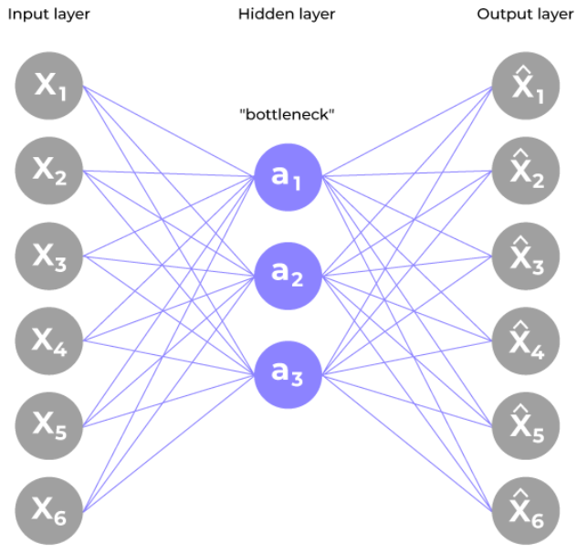
- Feature Learning: Extracts important features from unlabeled data for tasks like classification and clustering.
- Dimensionality Reduction: Compresses high dimensional data while preserving essential information.
- Anomaly Detection: Identifies unusual inputs that deviate from learned patterns.
- Denoising: Reconstructs clean data from noisy inputs.
- Pretraining Networks: Provides a strong weight initialization for deep networks.
- Interpretable Representations: Sparse activations highlight the most informative features.

*Undercomplete Autoencoders :-
An Undercomplete Autoencoder is a type of autoencoder where the dimension of the hidden layer (latent representation) is smaller than the dimension of the input data.
It is termed "undercomplete" because it forces the representation to have a lower dimensionality than the input itself, thereby learning to capture only the most essential features.
The goal of this architecture is not just to copy the input to the output, but to learn the most important features that can effectively represent the data in a compressed form.

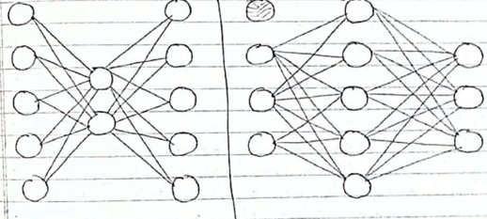

*Denoising Autoencoders :-
Denoising Autoencoders (DAEs) are a special type of autoencoder designed to handle corrupted or noisy input data. Their primary goal is to reconstruct the clean, original input from a deliberately noisy version of it.
During training, random noise is added to the input data, and the autoencoder is trained to minimize the reconstruction error between the original clean data and the output produced by the model. By learning to remove noise and recover the true signal, the model captures robust and meaningful features that are invariant to noise.
This process enables Denoising Autoencoders to improve generalization, making them highly effective for feature extraction, image denoising, and data compression tasks.
